Analyzing the Success Rate of Kickstarter Campaigns

By Ana Gill

**Purpose/background**

Crowdfunding is a method used to raise money to fund a project through many backers who invest or donate a small amount of money in return for a potential profit or reward.

Kickstarter is one of the most popular crowdfunding services on the internet. It has helped raise over $2 billion to fund creative arts projects over the years. In order to get funded on Kickstarter it is required that one meets or exceeds the project’s initial goal. With over 300,000 projects launched on Kickstarter only a third have made it through the funding process. This project will analyze a database of 4,000 past projects in order to evaluate the likelihood of a successful launch and uncover trends that may assist with breaking the one in three campaign success rates.

**Description of data sources/cleaning (EDA, visualizations)**

The data source represents data taken from more than 4,000 past projects on Kickstarter. This includes projects for 21 countries that fall under 9 categories and 41 subcategories. Data to be considered as potential indicators of project success include state of project, percent funded (pledge/goal*100), categories, subcategories, date project launched, and the deadline to acquire the funding. The records provided from the database indicated dates from May 2009 to March 2017. Knowing the facts that might impact the outcome of the project before launch can be extremely beneficial with only 54% of the projects reaching their funding goal.

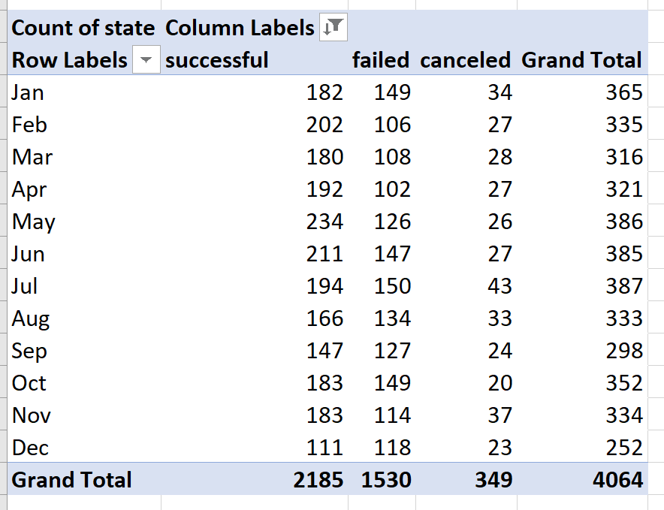

Fig 1. Shows the total successful projects

Modifications made to the excel table provided for analysis were:

1. Convert goal and pledge columns with Unix timestamps to regular date
2. Add percent funded column
3. Separate Category and Sub-Category column into two columns

**Model building/evaluation (metric visualizations/tables)**

The data analysis began by evaluating the state count of the dataset based on the date projects were created. The category, subcategory and timeline were also taken into account, concentrating on the projects with the successful and failed statuses.

The data analyzed covered a period from 2009 to 2017. The highest success rates occur during the months of February to May. The month of May appears to be the most favorable month to launch a project and the month of December the least favorable. The data shows a steep drop of successful projects during the month of December.

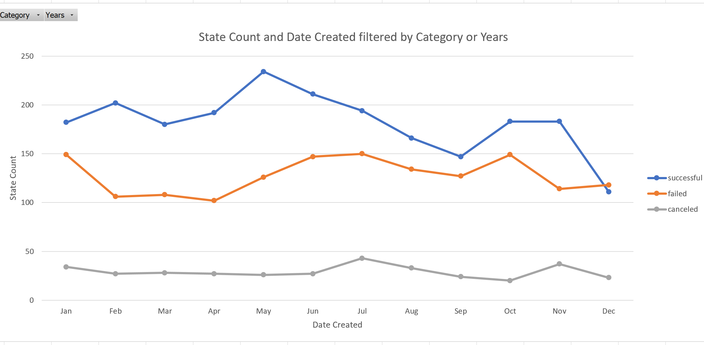

Fig 2. State Count for all Categories

The top 3 categories with the highest success rates are Music with a 79% success rate, followed by Theater with a 61% success rate, and Film and Video with a 57% success rate. The bottom 3 categories included Publishing at 33% success rate, Food with a 29% success rate, and Games with a 27% success rate.

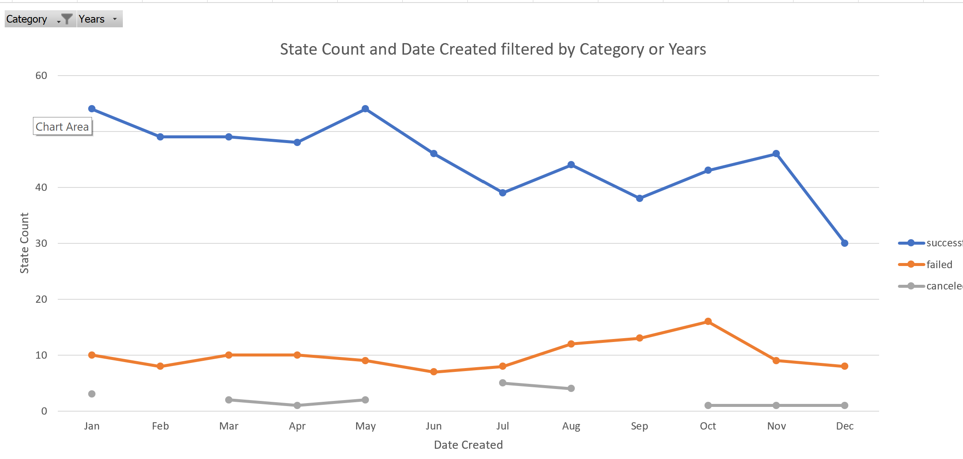

Fig 3. State Count for Music Category

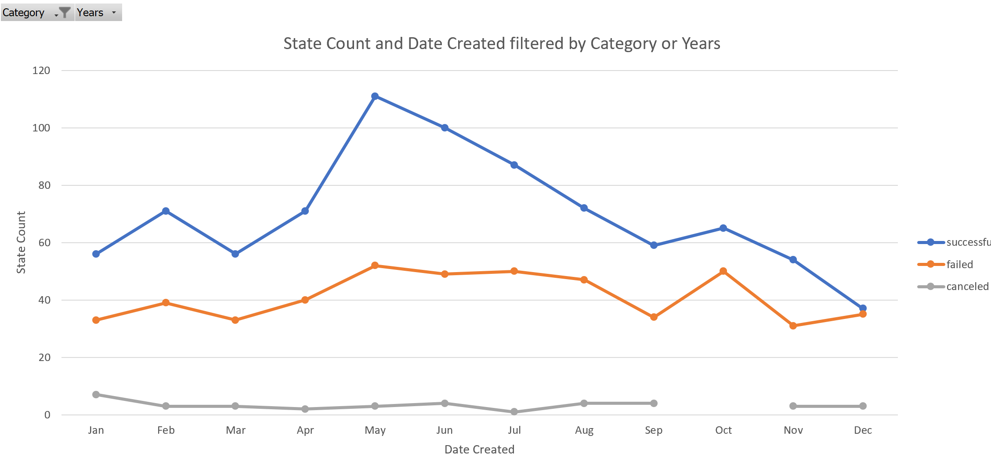

Fig 4. State Count for Theater Category

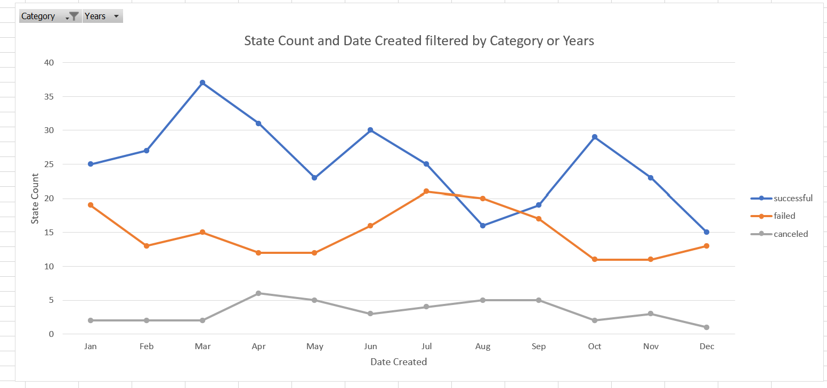

Fig 5 State Count for Film and Video Category

Further analysis of success rates for each category and sub-category point to differences among certain locations and how some locations performed better than others. For the top three categories the trend indicates a wide variation of success rates performance between categories and different locations. For the Theater category 17 of 21 countries show a successful project launch at 80% success rate verses 61% for all regions combined. The Music category shows 11 of 21 countries with a success project launch and a 52% success rate verses a 79% success rate for all regions combined. For the Film and Video category 8 of 21 countries show successful projects with 38% success rate verses 57% success rate for all regions combined. This trend indicates Theater projects are more successful when factoring in all countries.

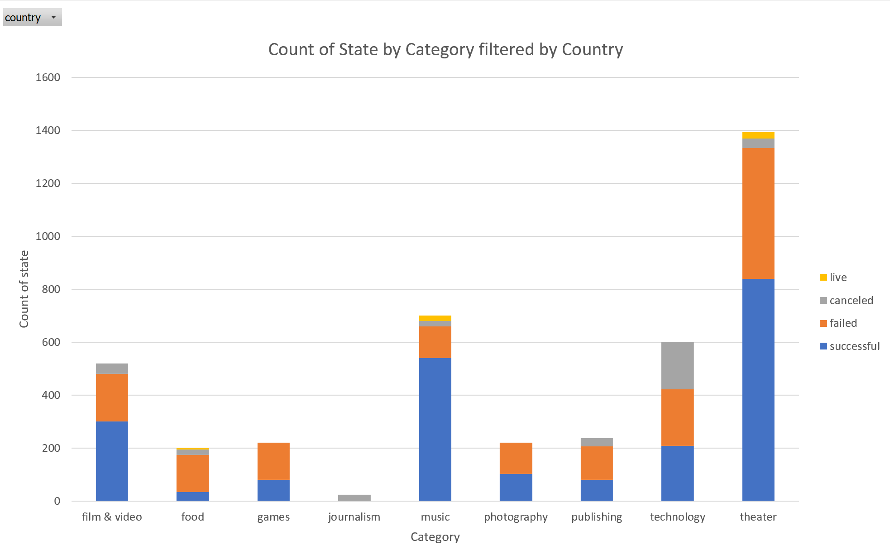

Fig 6. Shows Theater Category for all Countries

**Recommendation/findings**

What we can draw from the analysis is the launch of a project between the months of February to May can be advantageous as there is higher probability the project will be successful. There is an average of 202 successful projects during this period. The probability of a successful campaign diminishes greatly during the month of December. The chart, Fig. 1, shows a steep decline of successful projects during this month with 252 launched and 111 turning out successful.

Analysis also shows that Categories the campaigns fall under have a noteworthy deterrent on the successful launch of a project. The Music category has the highest success rates with 540 successful projects out of 700 total projects launched. Subcategories also play a part in the success rate as this appears to lower the success rate dramatically within some categories. For example, out of 41 possible subcategories found in the data Theater shows only 3 subcategories that make up the total amount of successful projects.

.

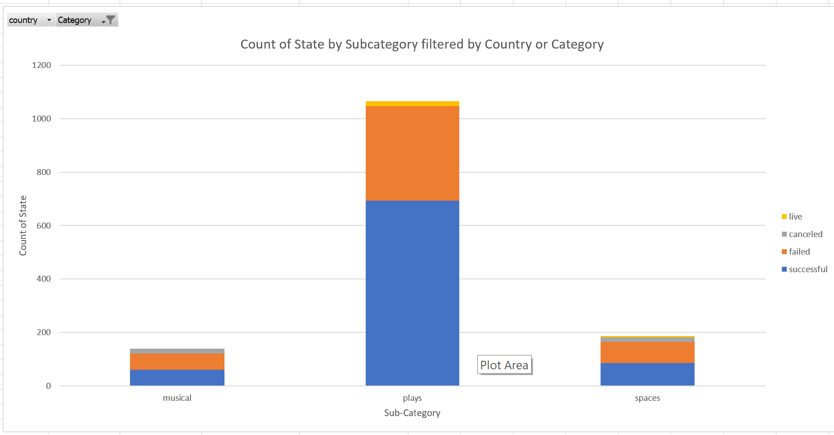

Fig 7. Theater per Sub-Category

Location is another noteworthy factor. Location affects the success rate within the top categories. There are 21 countries with 74% of projects being launched out of the United States. Music is the top category within all combined countries representing 79% success and declines to a 52% success rate when locations are taken into account individually.

**Conclusion**

This analysis shows there are several trends to consider when projecting the highest success rate. The time of year to launch a project is very important as some months show the highest level of successful campaigns. The category/sub-category combination is another important component determining the success of campaigns as some categories are not as popular as others. Lastly, location plays a part on the success of a project as some locations performed better than the rest.

**Limitations/future work**

Some of the limitations on this analysis include:

The size of the dataset as only a small portion of all projects are included.

The data provided does not include backer information to allow for further analysis.

There is no data provided on the amount of effort put into each campaign via updates, comments, etc.

Additional graphs that can be created to obtain additional information for analysis include:

Graph for time duration of projects related to successful projects.

Graph for the number of backers and amount of average donations.

Chart or graph on the number of actions to show effort put into launching successful campaigns.